



**Recruitment pack**

**Business Development Manager**

**January 2020**



**[](https://www.google.co.uk/url?sa=i&rct=j&q=&esrc=s&source=images&cd=&cad=rja&uact=8&ved=0ahUKEwif_cy-3OPXAhVInRoKHV5IC3QQjRwIBw&url=https://thehub.walthamforest.gov.uk/&psig=AOvVaw0KnwpFOt54NmDe_4U76f9t&ust=1512042766789460)**

**Welcome**

Thank you for wanting to find out more about becoming the Business Development Manager for Sir Josiah Mason Trust.

This is an extremely exciting time to join the Trust. We have been providing services for over 150 years and we are part way through an exciting 5 year Strategy. Over the past two years, we have embarked on an exciting period of transformation and growth which has led to an increase in services, the size and reputation of the organisation.

The Business Development Manager is a brand new role which has been developed to enable us further our exciting plans and to facilitate the growth of the Charity. The post holder will bring to the role vision, the ability to build relationships and work collaboratively and a successful track record of developing and delivering fundraising strategies and campaigns which have secured funds from industry, foundations, trusts and individuals.

In return, the post holder will be supported by a forward thinking, values driven leadership team and receive a generous benefits package including an annual "Wellbeing" day, a contributory pension scheme, a life assurance scheme, access to an Employee Assistance Programme and recognised training & personal development opportunities.

It is important to us is that we find the right people, with the abilities and experiences and values we need as the charity moves forward.

As Business Development Manager, you will be at the centre of the organisation, helping us to make a difference to hundreds of people every year. Therefore, it is important that you are a talented, driven and highly experienced fundraiser and that you share our values and vision.

We hope you’ll consider joining us.



David Healey

Chief Executive

**About Sir Josiah Mason Trust**

**We are Sir Josiah Mason Trust: a local charity with a proud history of supporting people in need for over 150 years.** We offer access to opportunities, hope and a place to belong.

We do this by providing safe, secure, affordable and well maintained housing, residential care and extra care housing for adults in their older age and education and support to young people from disadvantaged communities.

The Trust is a registered charity and a limited company and the parent of a group of charities.   We are also a Housing Association registered with Homes England and our care home and domiciliary care service is CQC registered.

**Our Vision:** We want everyone, regardless of age or circumstances, to feel secure, have opportunities and to thrive.

**Our Mission:** To offer people in need access to opportunities, hope and a place where they belong through the provision of quality housing, care, support and education.

**Our Values**

**Personalised**– because no two people are the same

**Dignity**– because everyone is worthy of honour and respect

**Innovation**– because we are original and creative in our thinking

**Excellence**– because we want to be recognised for providing quality services & support

**Honesty** – because we are transparent and accountable in all that we do

**Fun**– because we want to be a great place to work and receive support

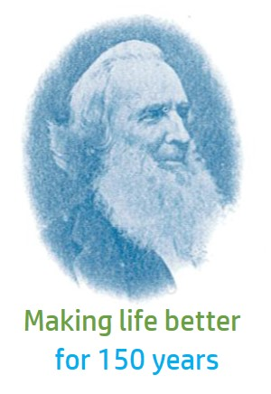

**Our history**

Sir Josiah Mason Trust was founded in 1868 by Josiah Mason, a Victorian industrialist and philanthropist.

Sir Josiah was born in 1795 in Kidderminster, a 'self-made man with no advantages of birth, or connections, or education, or means'. Born 17 years before Charles Dickens began to write about the poverty of the Victorian era, Josiah taught himself to write and joined a Unitarian Sunday School as they could provide him with a basic education. He went on to build a vast fortune from self-taught engineering skills and astute business knowledge.

From an early age, Josiah showed an entrepreneurial flare and tried his hand at many inventions, trades and business ventures before moving to Birmingham in 1816. By 1824, he invested the savings he had earned into a business which manufactured split rings. It was here that he improved the machinery that made the rings so that it was bevelled, hence the modern day key ring. He later went on to become the largest manufacturer of steel pens and pen nibs in the World and contributed heavily to the Birmingham pen trade. He also improved the machinery to make the split pen nib.

Josiah, most likely influenced by his childhood experiences was an extremely caring and generous man who went on to do many charitable works, including the founding of schools, a dispensary and Mason Science College, the forerunner of the University of Birmingham. He was knighted for his good works in November 1872.

**The Trust**

​In 1858, Josiah built the first Almshouses in Station Road, Erdington for 30 'spinsters and widows' over 50 years old and rooms for 20 orphan girls. These Almshouses were demolished in 1974.

It was 10 years later that the Trust was officially founded on the 29th July 1868, in readiness for the opening of a second, larger orphanage in Bell Lane (now Orphanage Road), Erdington, with rooms for 26 women and dormitories for 300 children. It cost £60,000 to build and was endowed to the sum of £200,000. All of this was financed by Sir Josiah and it amounted to a huge fortune at this time. Later a new wing was added to enable a total of 500 children to be accommodated. The orphanage was eventually re-designated as a school, but by the 1960's the cost of upkeep had become prohibitive, leading the Trustees to close it in 1960.

The Trust retained ownership of a small part of the Orphanage site which contained 36 Almshouses built in the 1920's and which are now called Mason Cottages. It then went on to build further Almshouses on our sites in Shirley and Olton.

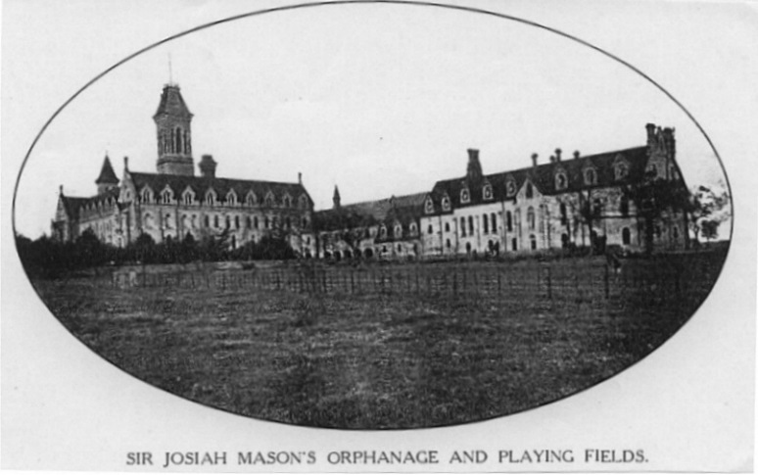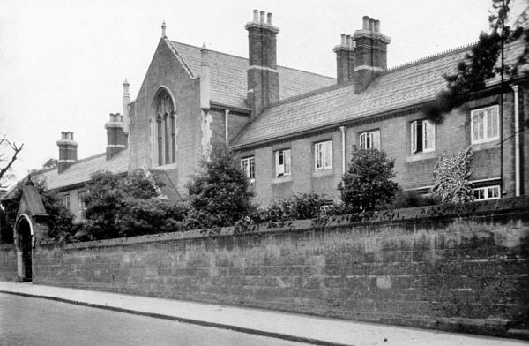

The Trust has continued to grow and evolve over the years and the need for the Trust is as real today as it was 150 years ago. We now enter an exciting and ambitious new phase of development in which we aim to improve the lives of many more people living in Birmingham and Solihull.

**Our future**

In January 2018, we launched our new ambitious 5 year Strategy ‘Building on strong foundations’.

Our 5 main goals are:

1. To be a leading provider in Birmingham & Solihull
2. To help more people
3. To be an employer of choice
4. To maintain financial sustainability and grow
5. To be the best we can be

Our Strategy brochure can be found on our website or sent to you on request.

The next few years promise to be an exciting period of time during which we will increase and improve our housing stock, review and modernise our care provisions and after nearly 60 years, return to the direct delivery of services for children and young people.

**Our linked charities:**

1. Sir Josiah Mason's Almshouse Charity
2. Sir Josiah Mason's Care Charity
3. Sir Josiah Mason's Relief in Need and Educational Charity
4. Holte & Bracebridge Charity
5. Holy Trinity Heath Town Almshouse Charity

**About the role**

**Job Summary and Purpose:**

The Business Development Manager is responsible for developing and implementing the Trust’s Income Generation Strategy in order to achieve income targets in line with the objectives outlined in the Strategic Business Plan.

They are responsible for identifying and securing income through contracts and grants from a range of sources (including trusts and foundations, NHS/local authority and government funding) and through developing strong and lasting relationships with potential high value donors and corporate sponsors/fundraisers.

**KEY RESPONSIBILITIES:**

**Strategy Development and implementation**

* To lead the development of the Trust’s Income Generation Strategy to achieve income targets across the range of revenue and capital streams.
* To diversify the mix of income streams, leading to a year on year growth in income and therefore securing the sustainability of the organisation.
* To lead efforts to increase philanthropic fundraising at the Trust.
* To contribute to the strategic direction and development of Sir Josiah Mason Trust.
* To work in partnership with the Chief Executive, Leadership Team and colleagues to understand fundraising ambitions to ensure they are reflected in the strategy.
* To identify new potential income streams and produce strategies to access these funds.
* To ensure that the fundraising strategy and its implementation is compliant with all appropriate legislation.

**Business Development**

* To identify new opportunities; undertake analysis of the sectors that SJMT operates in.
* To source and evaluate tenders, funding, contracts, donors and potential new business opportunities and partnerships
* To identify potential partners and associates, developing a range of relationships across sectors that lead to joint proposals and bids for grant-funded and commercial work

**Fundraising**

* To adopt a target-driven approach, focused on results in terms of donor and prospect recruitment, cultivation, solicitation and stewardship.
* To manage a pool of potential donors from a mixed portfolio of individuals, corporates and trusts and foundations
* To lead the engagement planning with the Leadership Team and other colleagues across the Trust to build and enhance relationships with funders, grant-providers, donors etc.
* To create compelling and innovative proposals in collaborations with colleagues to engage and secure commitment from donors.
* To conduct efficient and effective data entry and storage to provide a base for timely, accurate and appropriate operational and management information.
* To maintain high quality communication with donors, prospects, and Trust colleagues.
* To create robust and wide ranging case for support which can be used to generate specific marketing (e.g. case studies, impact info graphics)
* To achieve targets agreed with the CEO in terms of income, number of requests, prospects in active cultivation, repeat donations, positive endorsements of the Trust by supporters etc.

**Bid writing**

* To research and analyse potential grants and tender opportunities from trusts/corporations/local authorities/NHS and submit recommendations to the CEO for approval.
* To prioritise, prepare and submit persuasive funding applications and tender bids to producing relevant plans
* To work closely with the Finance Team to cost work and to compile required evidence.
* To ensure that information is obtained where required from relevant colleagues with specific expertise, potentially through the formation and oversight of a bid wirting group.
* To develop tactics to ensure that we are identifying and winning the right tenders in line with our vision, values, expertise and Strategy.
* To maintain a central register of all tenders being submitted and the outcomes.

**Networking & Personal Development**

* To network with external organisations from time to time and ensure that through personal development and attending training that the post holder is always up-to-date with ‘best practice’ requirements.

**Performance Reporting**

* To maintain up to date records and to provide regular reports to the CEO, Leadership Team and Board of Trustees
* To work closely with the Finance and Leadership Team and other relevant services
* To monitor the progress and outcomes and to disseminate the positive impact of the work of the Trust
* To contribute to the compilation of impact reports that showcase the relevance and significance of our work to funders, partners and supporters of our organisation.

**General Responsibilities**

* To establish and maintain positive working relationships with relevant partner agencies.
* To work in accordance with health and safety legislation.
* To be committed to improvements, innovation and advances in our sector
* To work within confidentiality applying the principles of data protection to record keeping and data sharing, and compliance with the Data Protection Act/GDPR.
* To promote the organisation and its values and beliefs at all times to maintain its good reputation.
* To attend and complete all mandatory training, adopting up to date and relevant knowledge within the working practice.
* To take responsibility for your own personal and professional development.
* To offer suggestions, advice and comments towards continuous improvement in a structured and constructive way.
* To be flexible to work occasional weekend and evening sessions on a rota.
* To carry out any other duties commensurate with the role, as required

**PERSON SPECIFICATION**

|  |  |  |  |
| --- | --- | --- | --- |
|  | ***ESSENTIAL*** | ***DESIRABLE*** | ***METHOD OF ASSESSMENT*** |
| **EXPERIENCE** | * Experience of being successfully awarded significant funding following writing funding applications/tenders for a medium/large charity * Experience of writing and implementing fundraising strategies/plans * Experience of successful business development activity in a charity or social enterprise * Experience of working with high value donors * Experience of working with corporate bodies in the pursuit of fundraising and high value donations | * Experience of working in the housing or health/social care or education sectors | Application/Interview  Application/Interview  Application/Interview  Application/Interview  Application/Interview |
| **QUALIFICATONS/ KNOWLEDGE** | * Educated to degree level or equivalent * Evidence of continued professional development * In depth knowledge of the different mediums of fundraising | * Recognised fundraising qualification * Knowledge of current government policy and best practice in our area of work | Application  Application  Application/Interview  Application/Interview |
| **SKILLS** | * Excellent oral, written and presentational and communication skills * Ability to engage with a diverse range of people and to adjust your approach accordingly * Ability to organise events and meetings * Good numerical skills and the ability to write and analyse budgets and collate information accurately * Excellent IT skills * Ability to analyse and interpret data * Good report writing skills * Able to work independently and within a team | * Existing local relationships or knowledge of potential high value sponsors/donors | Application/Interview  Application/Interview  Application/Interview  Application/Interview  Application/Interview  Application/Interview  Application/Interview  Application/Interview |
| **OTHER** | * Ability to work flexibly, including occasional evening and weekends in line with the requirements of the role * Car driver with access to a vehicle during working hours * Commitment to continuing professional and personal development and to developing best practice. * A creative, can-do attitude. * Keen and active interest in the work of the Trust * Shares the values of SJMT |  | Application  Application  Interview  Interview  Interview  Interview |

**How do I apply?**

If you would like to apply for this role, you will need to complete our Application Form which can be downloaded from our website: [WWW.SJMT.ORG.UK](http://WWW.SJMT.ORG.UK) along with an up to date CV.

**Applications must be received by noon on Friday 21st February 2020**

**Interviews will take place on Thursday 27th February 2020**

If at any point in the process you want to talk things over, then please feel free to give the Chief Executive, David Healey, a call on 0121 245 1001.

Good Luck with your application!